

**ANALOGUE AND DIGITAL COMMUNICATION (EL-3003)**

**PROJECT REPORT**

**Submitted by:**

**Name1 & Name2**

**Section: 5B1**

**CONTENTS**

* ABSTRACT
* INTRODUCTION AND BACKGROUND
* PROCEDURE AND RESULTS
* DISCUSSION OF RESULTS
* CALCULATIONS AND SUGGESTIONS FOR FUTURE IMP

**ABSTRACT:**

This project involves pulse position modulation, in which the information is stored in the position of the pulse. We utilized a message signal and a carrier signal and generated the Pulse Width Modulation and Pulse Position Modulation using an op-amp comparator, a 555 timer IC, and an LC low pass filter to demodulate the PPM.

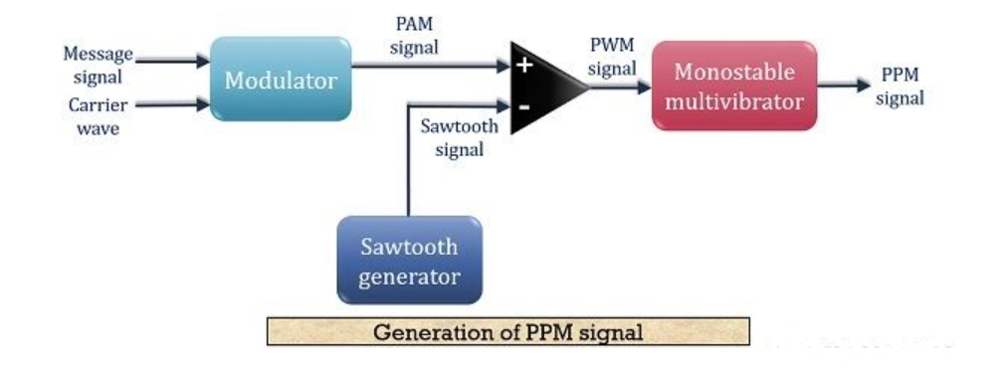

**INTRODUCTION/BACKGROUND**

PPM is an analog modulating technique where the position of each pulse in relation to a reference pulse varies depending on the instantaneous sampled value of the message signal while the amplitude and breadth of the pulses are kept constant.

To keep the transmitter and receiver in sync, the transmitter must deliver synchronizing pulses, also known as sync pulses. These sync pulses aid in keeping the pulses in place.

According to the pulse width modulated signal, pulse position modulation is applied. Every tail of the pulse width modulated signal serves as the beginning of a PPM signal pulse. As a result, the relationship between the position of these pulses and the PWM pulse width is established.

The modulation approach seeks to match the informational signal's frequency range to the transmission channel. This lessens the impact of the noise and prevents a significant attenuation of certain frequencies on the transmission channel. Additionally, the narrow band transmission modulation approach, which necessitates a transposition of the low frequencies towards the high frequencies, is utilized when transmitting the informative signal (or helpful information) over long distances. There are several forms of modulation depending on the carrier signal's nature and the information signal's (analog or digital) nature (analogical or digital). The type of modulation to select actually depends on the practical application. Frequency transposition is required for baseband transmission or transmission over short distances. This type of transmission utilizes copper wire, coaxial cable, the twisted pair or optical fiber as physical support; to transport pulse trains. In this article, we consider the narrow band transmission. We choose an informative signal of low-frequency analogical nature (for example the human voice) and a carrier signal of high-frequency digital nature (for example the clock signal). For frequency transposition, we use a modulator with adapted sensitivity. Indeed, we simulate signals modulated in amplitude (PAM, Pulse Amplitude Modulation), in width (PWM, Pulse Width Modulation), and in position (PPM, Pulse Position Modulation). On an illustrative basis, we simulated the case of an audio informative signal. We analyze obtained results from the simulation and recall the advantages, disadvantages, and applicability of each type of modulation. The modulation software used is ISIS from proteus. Let us mention that obtained results from the simulation are a little different from those of the real world because of the performance of the utilized

Software and other environmental parameters. PAM, PWM, and PPM modulations are particularly employed for the analogical transmissions of the signals on optical fibers, in remote control IRE or telemetry.

The technique of modulation allows the transmitted signal to have the same band frequency as the message signal.

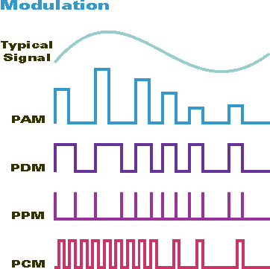

**PROCEDURE AND RESULTS**

With the use of Google, we performed a search, discovered the PPM block diagram, and then used Proteus to create a circuit.

We used the op-amp as a comparator and fed the message and carrier signals to it in accordance with the block diagram.

For the demodulation of PPM, we attached a Low Pass Filter as an LC low filter for the demodulation of PPM of our circuit.

**Proteus Design**

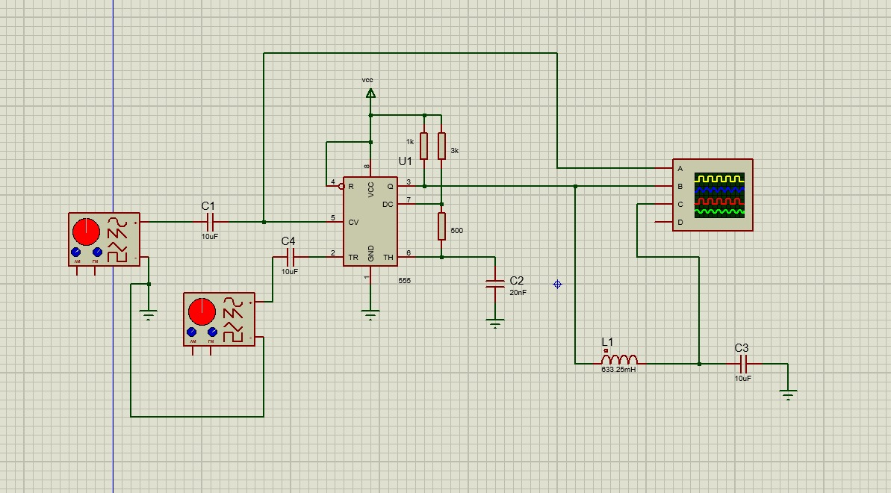

**Simulation Result**

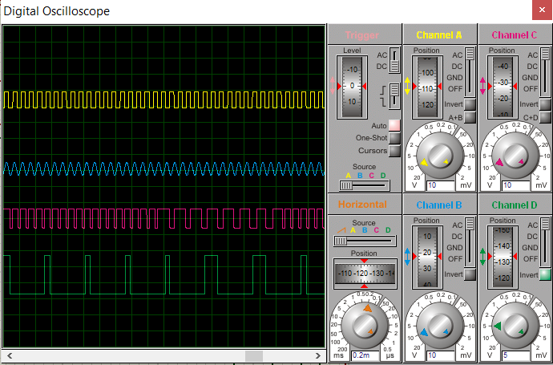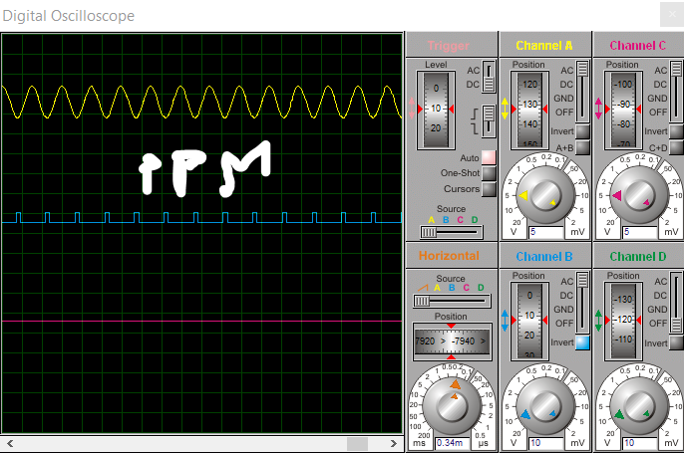

For demodulation of PPM we need LOW PASS Filter so we can use the LC low filter for the demodulation of PPM in our Circuit.

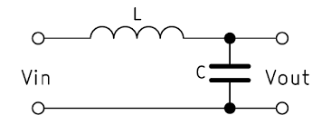

So we used this circuit to demodulate the our PPM modulation

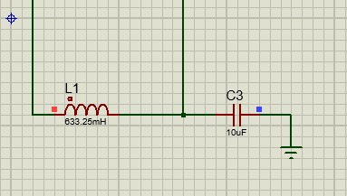

**Components List**

* Breadboard

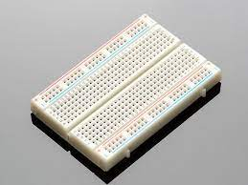

* Resistors

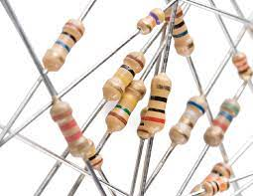

* Oscilloscope

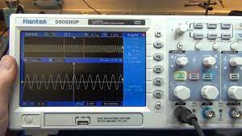

* Capacitors

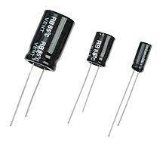

* 555 timer IC

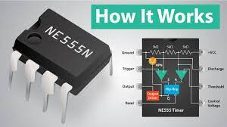

* Jumper Wires

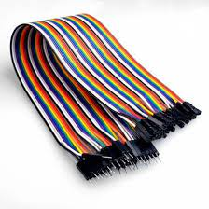

* Inductor

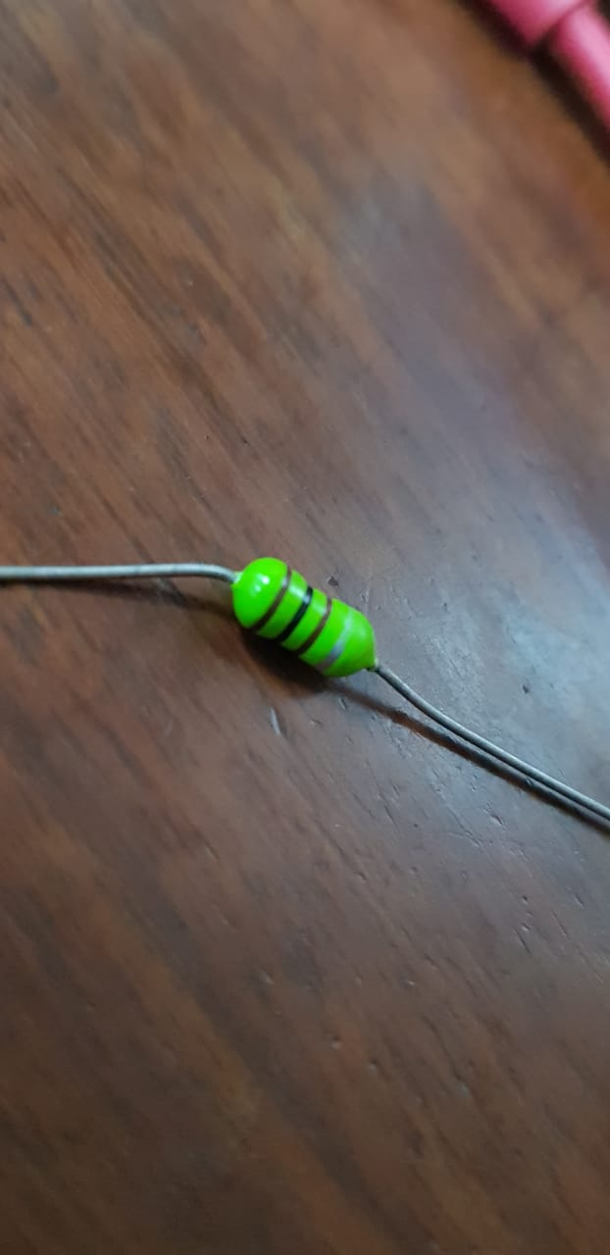

**Estimated Cost of Components**

* Breadboard = 300 Rupees
* Resistors = 50 Rupees
* Capacitors = 300
* 555 timer IC = 120 Rupees each = 240 Rupees
* Jumper Wires = 1000 Rupees
* Inductor =200 Rupees
* DC Battery= 100 Rupees

**Schedule**

|  |  |  |  |  |  |  |  |
| --- | --- | --- | --- | --- | --- | --- | --- |
|  | 2-12-2022 | 3-12-2022 | 4-12-2022 | 5-12-2022 | 6-08-2022 | 7-12-2022 | 8-12-2022 |
| Defining Project Goals |  |  |  |  |  |  |  |
| Designing Circuits on Proteus |  |  |  |  |  |  |  |
| Designing the circuit |  |  |  |  |  |  |  |
| Implementing The circuit on Breadboard |  |  |  |  |  |  |  |
| Project Report |  |  |  |  |  |  |  |
| Flow-chart |  |  |  |  |  |  |  |
| Reviewing All |  |  |  |  |  |  |  |

**Task Division**

|  |  |  |
| --- | --- | --- |
|  | -------- | -------- |
| Defining Project Goals |  |  |
| Designing Circuits on Proteus |  |  |
| Implementing the Circuit |  |  |
| Making Design for the circuit |  |  |
| Project Report |  |  |
| Flow-chart |  |  |
| Reviewing All |  |  |

We had good coordination with each other throughout the project duration. Mostly we did tasks jointly so that both can understand the concepts of the project clearly, rather than explaining different parts to each other after the completion of the project.

**Flow-chart**

START

Doing the calculations



Defining project goals

Designing circuit on proteus



Implementation circuit on breadboard









**DISCUSSION OF RESULTS**

We achieved our desired outputs from the desired but we were not able to implement the demodulation of the circuit as for some reason the lc low pass filter was not working

**CONCLUSION AND SUGGESTION FOR FUTURE IMPROVEMENTS:**

* Increase the number of transmitted pulses: Increasing the number of transmitted pulses can improve the signal-to-noise ratio, which can lead to higher data rates.
* Improve the design of the receiver: Improving the design of the receiver can help to reduce noise and interference, leading to a better signal-to-noise ratio.
* Increase the bandwidth of the transmission: Increasing the bandwidth of the transmission can allow for more data to be transmitted, leading to higher data rates.
* Use adaptive pulse position modulation: Adaptive pulse position modulation (APPM) can be used to improve the performance of the system. APPM uses feedback from the receiver to adapt the pulse positions, which can improve the signal-to-noise ratio.

**Conclusion:**

To conclude, in this project, we applied the concepts to use the 555 Timers PPM IC. Also, we learned Using Proteus, to implement the PPM. Being aware of the fundamental rules of communication was another learning outcome from this projet4) to being familiar with electrical engineering tools. The implementation of the knowledge we learn in the analog and digital communication courses is a key goal of this project. However we were not able to implement the demodulation circuit.

**Suggestions:**

For suggestions for future improvement, the RLC low pass filter circuit can be used for more accurate message recovery and we need fewer value resistors so because on proteus we can easily use any value resistor, capacitor, and inductors but in hardware, it will be efficient to use less amount of devices to perform the task and that will be good and environmentally friendly.